Hexagonal Cupola
# Source: AI Source: Provided by: [Data Path: Persons Table -> ID Column: 1, Name_En Column: Motasem Essam] -> From: [ChatGPT] on [7/25/2026]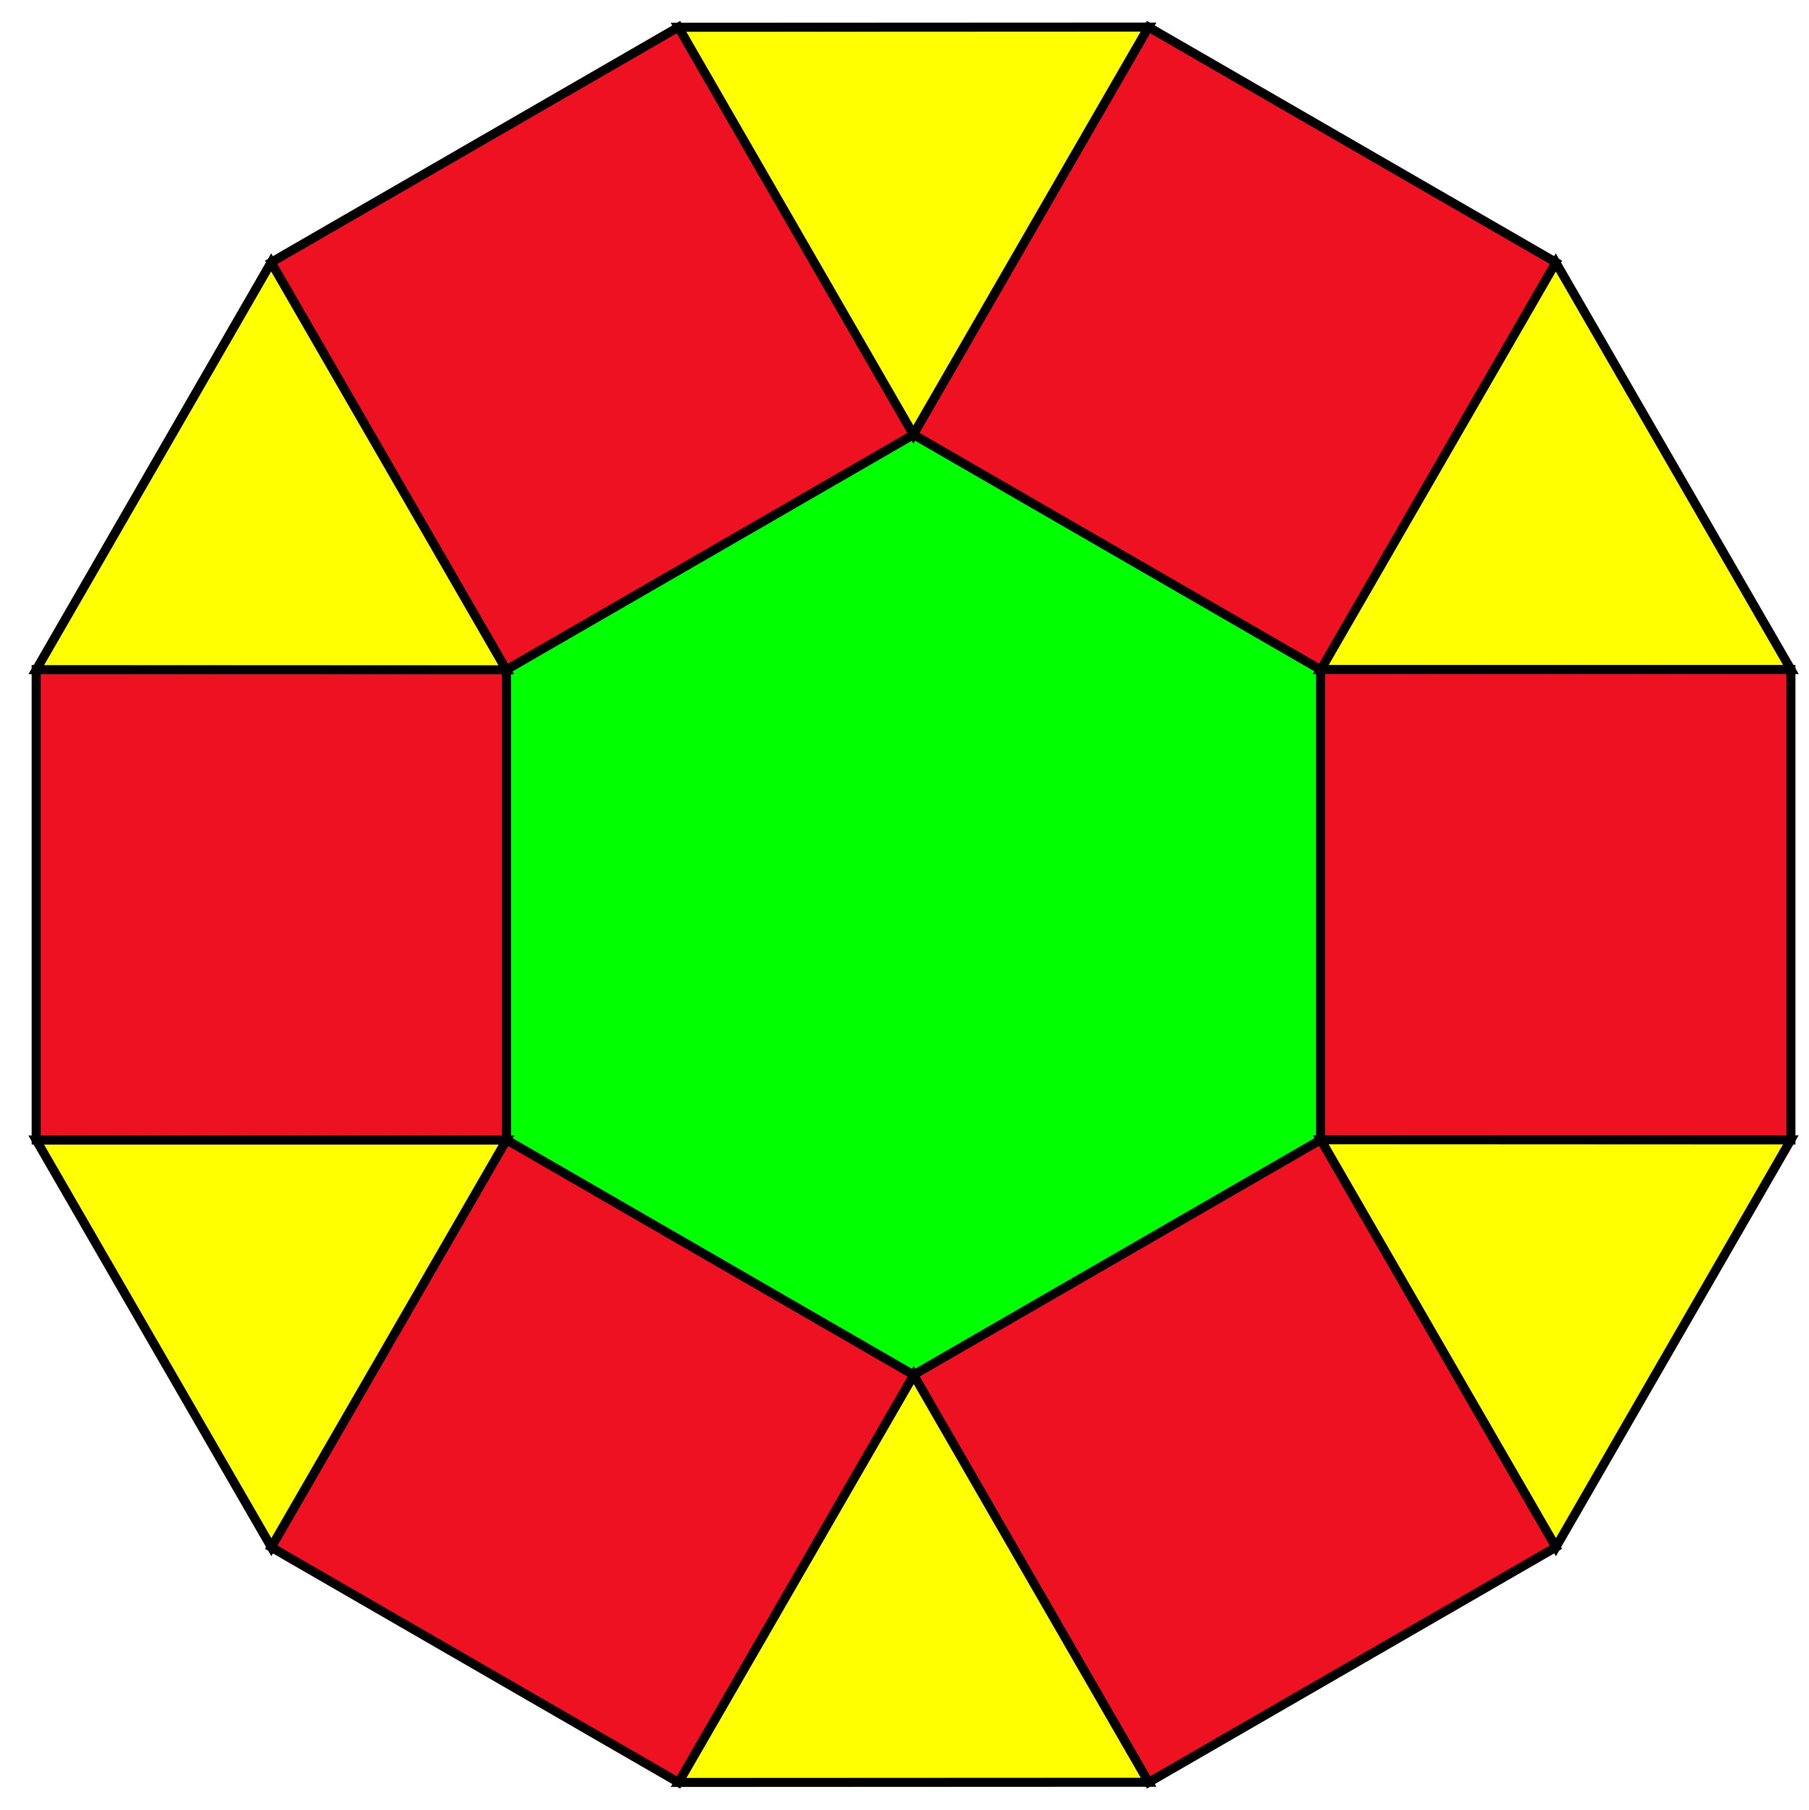

Definition
# Source: AI Source: Provided by: [Data Path: Persons Table -> ID Column: 1, Name_En Column: Motasem Essam] -> From: [ChatGPT] on [7/25/2026]
A Hexagonal Cupola is a three-dimensional polyhedron consisting of:
- One hexagonal upper base.
- One regular dodecagonal lower base.
- Six equilateral triangular lateral faces.
- Six square lateral faces.
The two bases are parallel, and the triangular and square lateral faces alternate around the sides of the cupola.
Note: The generalized Hexagonal Cupola is not one of the 92 Johnson solids. Unlike the square and pentagonal cupolas, it cannot have all its faces regular while maintaining the standard cupola structure.

Geometric Structure
# Source: AI Source: Provided by: [Data Path: Persons Table -> ID Column: 1, Name_En Column: Motasem Essam] -> From: [ChatGPT] on [7/25/2026]
- Upper Base: A regular hexagon.
- Lower Base: A regular dodecagon (12-sided polygon).
- Lateral Faces: Twelve faces arranged alternately:
- 6 equilateral triangles.
- 6 squares.
- Arrangement: The hexagonal base is positioned above the dodecagonal base, with alternating triangular and square faces connecting their edges.

Face Composition
# Source: AI Source: Provided by: [Data Path: Persons Table -> ID Column: 1, Name_En Column: Motasem Essam] -> From: [ChatGPT] on [7/25/2026]
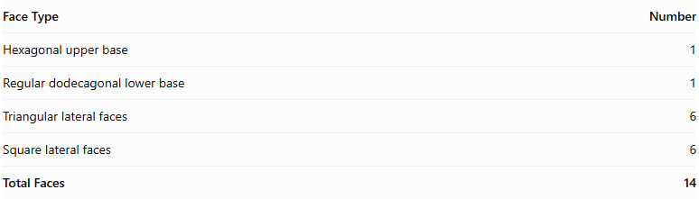
Face Type | Number
Hexagonal upper base | 1
Regular dodecagonal lower base | 1
Triangular lateral faces | 6
Square lateral faces | 6
Total Faces | 14

Mathematical Properties
# Source: AI Source: Provided by: [Data Path: Persons Table -> ID Column: 1, Name_En Column: Motasem Essam] -> From: [ChatGPT] on [7/25/2026]
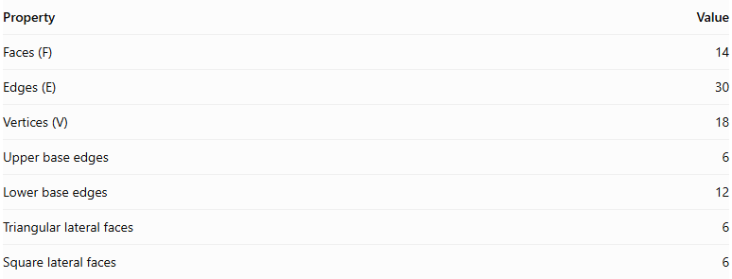
Property | Value
Faces (F) | 14
Edges (E) | 30
Vertices (V) | 18
Upper base edges | 6
Lower base edges | 12
Triangular lateral faces | 6
Square lateral faces | 6
Euler's Formula:
$$V-E+F=2$$
$$18-30+14=2$$
<badge color="success">Euler's formula verified</badge>

Geometric Characteristics
# Source: AI Source: Provided by: [Data Path: Persons Table -> ID Column: 1, Name_En Column: Motasem Essam] -> From: [ChatGPT] on [7/25/2026]
- The hexagonal and dodecagonal bases are parallel.
- The upper hexagon has 6 vertices.
- The lower dodecagon has 12 vertices.
- The lateral faces alternate between triangles and squares.
- The solid can have rotational symmetry of order 6 when its geometry is arranged symmetrically.
- It is a convex polyhedron when constructed without inward deformations.

Constructing Hexagonal Cupola in Solid Geometry

Geometric Instruments Used
# Source: AI Source: Provided by: [Data Path: Persons Table -> ID Column: 1, Name_En Column: Motasem Essam] -> From: [ChatGPT] on [7/25/2026]
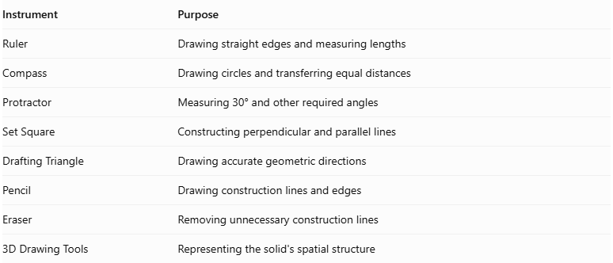
Instrument | Purpose
Ruler | Drawing straight edges and measuring lengths
Compass | Drawing circles and transferring equal distances
Protractor | Measuring 30° and other required angles
Set Square | Constructing perpendicular and parallel lines
Drafting Triangle | Drawing accurate geometric directions
Pencil | Drawing construction lines and edges
Eraser | Removing unnecessary construction lines
3D Drawing Tools | Representing the solid's spatial structure

Instrument-Based Construction Procedures
# Source: AI Source: Provided by: [Data Path: Persons Table -> ID Column: 1, Name_En Column: Motasem Essam] -> From: [ChatGPT] on [7/25/2026]
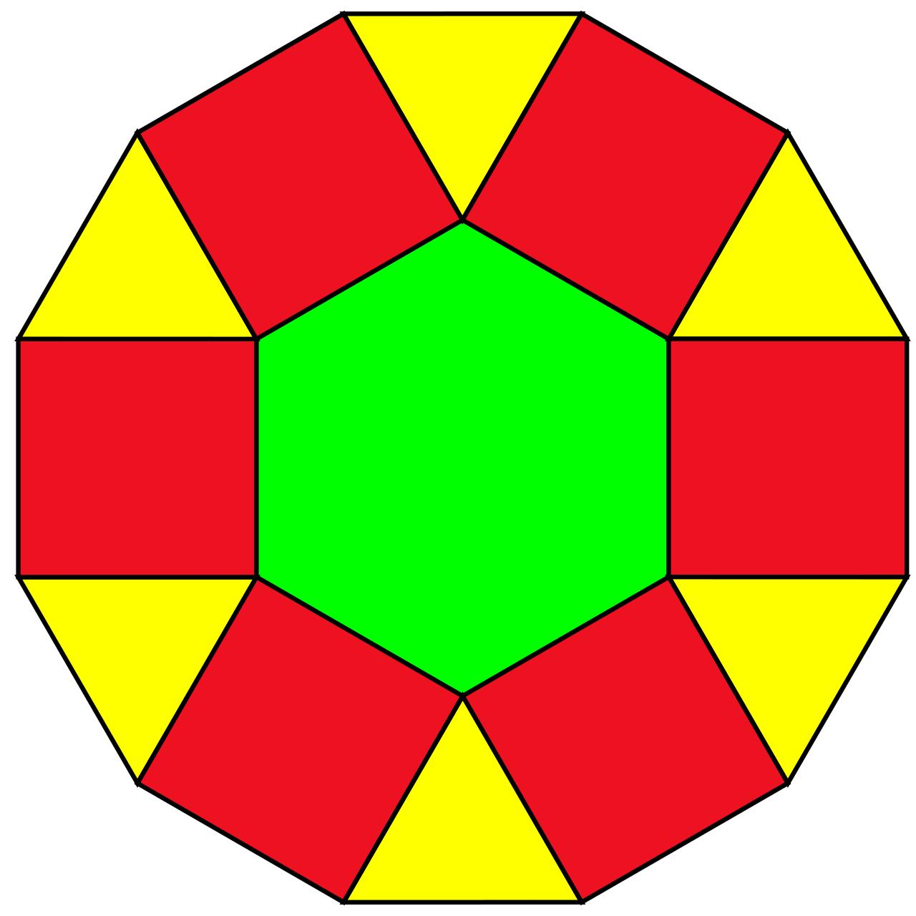

Constructing the Dodecagonal Base
# Source: AI Source: Provided by: [Data Path: Persons Table -> ID Column: 1, Name_En Column: Motasem Essam] -> From: [ChatGPT] on [7/25/2026]
- Draw a circle using a compass.
- Divide the circle into twelve equal angular sections using a protractor, with a central angle of ${30}^{°}$.
- Mark the twelve points on the circumference.
- Connect consecutive points using a ruler.
- Complete the regular dodecagonal base.

Constructing the Hexagonal Upper Base
# Source: AI Source: Provided by: [Data Path: Persons Table -> ID Column: 1, Name_En Column: Motasem Essam] -> From: [ChatGPT] on [7/25/2026]
- Draw a regular hexagon using a ruler and compass.
- Make each side equal to the required common edge length.
- Position the hexagon parallel to the dodecagonal base.
- Align the hexagon so that its six vertices correspond to the appropriate alternating positions around the lower base.
- Establish the required perpendicular separation between the two base planes.

Constructing the Lateral Faces
# Source: AI Source: Provided by: [Data Path: Persons Table -> ID Column: 1, Name_En Column: Motasem Essam] -> From: [ChatGPT] on [7/25/2026]
- Identify the six alternating groups of vertices around the dodecagonal base.
- Connect the appropriate dodecagonal vertices to the six vertices of the upper hexagon.
- Construct six square lateral faces between the corresponding base edges.
- Construct six equilateral triangular lateral faces between the square faces.
- Check that the triangular and square faces alternate around the solid.
- Ensure that all shared edges have matching lengths.

Finalizing the Solid
# Source: AI Source: Provided by: [Data Path: Persons Table -> ID Column: 1, Name_En Column: Motasem Essam] -> From: [ChatGPT] on [7/25/2026]
- Draw the visible edges using continuous lines.
- Represent hidden edges using dashed lines where necessary.
- Check the arrangement of all fourteen faces.
- Verify that the hexagonal upper base and dodecagonal lower base are parallel.
- Erase unnecessary construction lines.
- Complete the three-dimensional representation.
Construction note: This is an instrument-based geometric construction using rulers, compasses, protractors, and geometric relationships. It is not coordinate-based construction.

Key Points
# Source: AI Source: Provided by: [Data Path: Persons Table -> ID Column: 1, Name_En Column: Motasem Essam] -> From: [ChatGPT] on [7/25/2026]
- A Hexagonal Cupola has a hexagonal upper base and a dodecagonal lower base.
- It contains 6 triangular and 6 square lateral faces.
- It has 14 faces, 30 edges, and 18 vertices.
- It is a generalized cupola rather than a Johnson solid.

Classification
# Source: AI Source: Provided by: [Data Path: Persons Table -> ID Column: 1, Name_En Column: Motasem Essam] -> From: [ChatGPT] on [7/25/2026]
Solid Geometry
└── Types of Solids
└── Cupola
└── Types of Cupolas
└── Hexagonal Cupola

Conclusion
# Source: AI Source: Provided by: [Data Path: Persons Table -> ID Column: 1, Name_En Column: Motasem Essam] -> From: [ChatGPT] on [7/25/2026]
The Hexagonal Cupola is a polyhedron formed by connecting a regular hexagonal base and a regular dodecagonal base with six alternating triangular faces and six square faces. It has 14 faces, 30 edges, and 18 vertices.

